**Facilities, Equipment and Other Resources**

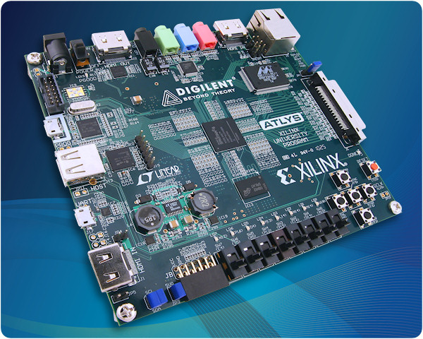We have two Atlys™ Spartan-6 FPGA Development Boards that are programmable through standard off-the-shelf desktop computers. UNM has licensed software packages necessary to synthesize circuits and transfer them to the board. These boards are portable and can be easily carried.

The UNM Computer Science Department has over 200 general-purpose workstations and servers running Linux, Windows and OS X. The department network infrastructure consists of a switched 1GB backbone, which links the campus network and supports the principal departmental servers. Workstations connect via Ethernet ports, based upon hardware class and usage, including 336 10/100 ports and 154 Gigabit ports provided by a redundant stack of Cisco 3750 switches. The CS Department has 4 class C subnets which are segmented into smaller broadcast domains.

Departmental services such as LDAP, DNS, DHCP, Subversion and Apache are hosted on redundant Xen servers. There are also five 8-core compute servers available for additional processing support. There is a departmental lab available to students with 18 workstations, primarily Linux, a classroom with 55 Linux based workstations, as well as several labs dedicated to specific research projects. The Computer Science Department also maintains a wireless network (80211.b) in the Farris Engineering Center for faculty and students. Additional labs are being planned. Systems support is provided by two full time staff and one part-time student.